Action full title:
Universal, mobile-centric and opportunistic communications architecture
Action acronym:
UMOBILE

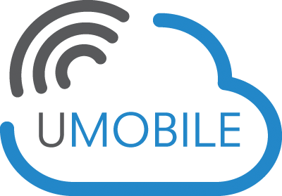

Deliverable:
D3.3 “UMOBILE ICN layer abstraction initial specification”
Project Information:
Project Full Title | Universal, mobile-centric and opportunistic communications architecture
Project Acronym | UMOBILE
Grant agreement number | 645124
Call identifier | H2020-ICT-2014-1
Topic | ICT-05-2014 Smart Networks and novel Internet Architectures
Programme | EU Framework Programme for Research and Innovation HORIZON 2020
Project Coordinator | Prof. Vassilis Tsaoussidis, Democritus University of Thrace

Deliverable Information:
Deliverable Number-Title | D3.3 UMOBILE ICN layer abstraction initial specification
WP Number | WP3
WP Leader | DUTH
Task Leader (s) | UCL
Authors | COPELABS: Paulo Mendes, Waldir Moreira  DUTH: Nikolaos Bezirgiannidis, Sotiris Diamantopoulos, Ioannis Komnios, Vassilis Tsaoussidis  UCL: Ioannis Psaras, Sergi Rene  UCAM: Jon Crowcroft, Adisorn Lertsinsrubtavee, Arjuna Sathiaseelan  TECNALIA: Susana Perez Sanchez, Iñigo Sedano  SENCEPTION: Rute Sofia
Contact | i.psaras@ucl.ac.uk, s.rene@ucl.ac.uk
Due date | M12: 31/01/2016
Actual date of submission | --/--/2016

Dissemination Level:
PU | Public | x
CO | Confidential, only for members of the consortium (including the Commission Services)
CI | Classified, as referred to in Commission Decision 2001/844/EC

Document History:
Version | Date | Description
Version 1 | 11/01/16 | First draft to the consortium for alignment with D3.3 and allocation of contributions
Version 2 | 22/01/16 | Second draft to the consortium for alignment with D3.3 and allocation of contributions
Version 3 | 29/01/16 | Third draft to the consortium for alignment with D3.3 and allocation of contributions

Table of Contents
List of Definitions 4
Executive Summary 8
1 Introduction 10
2. UMOBILE ICN-DTN integration: Application/Service perspective 12
2.1. UMOBILE Applications 12
2.1.1. Micro-blogging 12
2.1.2. Emergency Situation 12
2.1.3. Civil protection 12
2.1.4. Social Routine Improvement 13
2.2. UMOBILE Services 13
2.2.1. Communication models 14
2.2.2. Network services 16
3 UMOBILE Architecture Design 17
3.1 UMOBILE-enabled Proxy/Gateway 20
4. UMOBILE modules 22
4.1. Content Plane 22
4.1.1. Naming 22
4.2. Context Plane 24
4.2.1. Usage context 25
4.2.2. User context 26
4.2.3. Network context 27
4.3. Data sharing plane 30
4.3.1. Forwarding 30
4.3.1.1 Forwarding Module 31
4.3.1.2 Forwarding strategies 31
4.3.2. Flow control 35
4.4. Service Migration module 36
4.4.1 Service migration components 36
4.4.2 Service migration operations 37
4.4.3 IP-NDN Translation 38
5 Conclusion 40
References 41

List of Definitions
Term | Meaning
DTN | Delay Tolerant Network (DTN) is an emerging technology that supports interoperability of other networks by accommodating long disruptions and delays between and within those networks. DTN operates in a store-and-forward fashion where intermediate nodes can temporary keep the messages and opportunistically forward them to the next hop. This inherently deals with temporary disruptions and allows connecting nodes that would be disconnected in space at any point in time by exploiting time-space paths.
ICN | Information-Centric Network (ICN) has emerged as a promising solution for the future Internet's architecture that aims to provide better support for efficient information delivery. ICN approach uniquely identifies information by name at the network layer, deploys in-network caching architecture (store information at the network node) and supports multicast mechanisms. These key mechanisms facilitate the efficient and timely information (contents and services) delivery to the end-users.
Content | Content refers to a piece of digital information that is disseminated and consumed by end-user equipment.
Node | A wireless or wired capable device.
User | An entity (individual or collective) that is both a consumer and a relay of user services.
User Service | Context-aware services are considered as a set of mechanisms that assist incorporating information about the current surrounding of mobile users in order to provide more relevant of services.
User Interest | A parameter capable of providing a measure (cost) of the “attention” of a user towards a specific (piece of) information in a specific time instant. Particularly, users can cooperate and share their personal and individual interests that enable the social interactions and data sharing across multiple users.
User Requirement | User requirement corresponds to the specifications that users expect from the application.
Upstream | Upstream traffic refers to outgoing data such as short message, photo or uploading video clips that are sent from user equipment.
Downstream | Downstream traffic refers to data is obtained by use equipment from network. This includes downloading files, web page, receiving messages, etc.
Gateway | Gateway typically means an equipment installed at the edge of a network. It connects the local network to larger network or Internet. In addition, gateway also has a capability to store services and contents in its cache to subsequently provide local access communication.
Customer Premises | Customer Premises relate to residential households and enterprise market and are, as of today, controlled by the end-user.
User-centric | User-centric refers to a new paradigm leveraging user information at large to deliver novel content or services by users towards other users.
UMOBILE System | UMOBILE System refers to an open system that provides communication access to users through wired or wireless connectivity. This system exploits the benefit of local communication to minimize upstream and downstream traffic. The services or contents can be exchanged and stored in several devices such as gateways; user equipments; customer premises equipments such as Wi-Fi Access Points in order to efficiently delivery the desired contents or services to end-users.
UMOBILE Architecture | A mobile-centric service-oriented architecture that efficiently delivers contents and services to the end-users. The UMOBILE architecture integrates the principles of Delay Tolerant Networks (DTN) and Information-Centric Networks (ICN).
User-equipment | User-equipment (UE) corresponds to a generic user terminal (for example smart phone or notebook). In terms of UE and for operating systems we consider mainly smartphones equipped with Android; notebooks with UNIX, Windows, Mac OS.
Social Trust | Trust which builds upon associations of nodes is based on the notion of shared interests; individual or collective expression of interests; affinities between end-users.
Application | Computer software design to perform a single or several specific tasks, e.g. a calendar and map services. In UMOBILE, context-aware applications are considered.
Incentive | A factor (e.g., economic or sociological) that motivates a particular action or a preference for a specific choice.
Service | Service refers to a computational operation or application running on the network which can fulfil an end-user’s request. The services can be hosted and computed in some specific nodes such servers or gateways. Specifically, service is normally provided for remuneration, at a distance, by electronic means and at the individual request of a recipient of services. For the purposes of this definition;“at a distance” means that the service is provided without the parties being simultaneously present; “by electronic means” means that the service is sent initially and received at its destination by means of electronic equipment for the processing (including digital compression) and storage of data, and entirely transmitted, conveyed and received by wire, by radio, by optical means or by other electromagnetic means; “at the individual request of a recipient of services” means that the service is provided through the transmission of data on individual request. Refer to D2.2 for further details.
Trust Association | An unidirectional social trust association between two different nodes.
UMOBILE gateway | Role (software functionality) which reflects an operational behavior making a UMOBILE device capable of acting as a mediator between UMOBILE systems and non-UMOBILE systems – the outside world.
UAV | Unmanned Aerial Vehicle, which is an aircraft with no pilot on board.
BSS | Basic Service Set is a set consisting of all the devices associated with a consumer or enterprise IEEE 802.11 wireless local area network (WLAN). The service set can be local, independent, extended or mesh. Service sets have an associated identifier, the Service Set Identifier (SSID), which consists of 32 octets that frequently contains a human readable identifier of the network.
DC | Data Cache is responsible for holding information concerning the content carried by the current node.
CIT | Carried Interest Table is responsible for keeping up-to-date information concerning the data interests of the current node along with its social weights towards other nodes with whom it socially interacts.
SWM | Social Weight Measurer is responsible for keeping track of the contact duration between the current and encountered nodes.
SWR | Social Weight Repository is responsible for storing the list of interests the current node comes across (obtained upon encountering a peer).
tPIT | temporary Pending Interest Table holds the list of interests seen by the encountered node and the social weights between itself and such interests.
tCDT | Temporary Carried Data Table holds information about the data that the encountered node is currently carrying.
SWCDG | Social Weight and Carried Data Gatherer is responsible for obtaining the list of interests and social weights towards the encountered node.
DM | Decision Maker is responsible for deciding whether replication should occur based on the level of social interaction towards specific interests, based on the SCORP algorithm.
SC | Service Controller manages the mapping of publishers of services and subscribers of services in the service migration module.
SP | Service Publisher refers to the original content producer in the the service migration module.
SEG | Service Execution Gateway is the point of attachment for clients in the the service migration module.
FN | Forwarding Node is responsible for routing requests for services towards the available copies in the service migration module.
NDN | Named Data Networking

Executive Summary
This document covers the UMOBILE architecture ICN layer specification, as well as UMOBILE services that apply to scenarios detailed in D2.1, for the specification of the UMOBILE architecture. This document incorporates the first version of the UMOBILE architecture ICN layer specification and the final document D3.4 (to be provided on M30) will describe the refined ICN layer specification.
The final goal of this document is to provide a detailed description of the overall specification of the UMOBILE architecture. Special attention is given to the needed alignment with the Delay-Tolerant Network (DTN) architecture [1], and the most relevant proposal for an information-centric network architecture (ICN) [2] that fits the identified UMOBILE system and network requirements. The provided specification drives the development and implementation of the UMOBILE architecture, to be fully described in deliverable D3.1 (e.g. core platform, API, protocols).
The starting point for this report are deliverables D2.1 [3] and D2.2 (to be submitted on M14), which describes typical accessibility scenarios in different environments, namely, urban, remote and disaster areas, as well as requirements from the end-user (D2.1) and the system (D2.2) perspective. The UMOBILE architecture specification, provided in this document, will be complemented by the following deliverables:
- D3.1/D3.2 with a detailed specification of the UMOBILE architecture.
- D4.1 and D4.2 with a detailed specification of the proposed rate-regulation scheme.
- D4.3 with a detailed specification of the proposed mobile name-based replication scheme.
- D4.4 with a detailed specification of the different supported services.
- D4.5 with a detailed specification about sensing data collection and users’ behaviour inference.
The methodology used in this deliverable is as follows:
- Start from the applicability pictures identified in D2.1 and derive application services that must be implemented using the UMOBILE architecture.
- Identify the network services required for the services previously detailed.
- Describe the high-level design of UMOBILE architecture based on the overall assumptions and requirements, as well as the capabilities provided by the selected DTN and ICN architectures.
- Detail the different modules and describe the full specification of the UMOBILE ICN layer abstraction architecture, highlighting the components that need to be further described in D3.1, D4.1/D4.2, D4.3, D4.4 and D4.5

Introduction
The main objective of UMOBILE is to develop a mobile-centric service oriented architecture that efficiently delivers content/service to the end-users. UMOBILE decouples services from their origin locations, shifting the host-centric paradigm to a new paradigm, one that incorporates aspects from both information-centric and opportunistic networking with the ultimate purpose of delivering an architecture focused in: i) improving aspects of the existing infrastructure (e.g., keeping traffic local to lower OPEX); ii) improving the social routine of Internet users via technology-mediated approaches; iii) extending the reach of services to areas with little or no infrastructure (e.g., remote areas, emergency situations).
UMOBILE aims to push network services (e.g., mobility management, intermittent connectivity support) and user services (e.g., pervasive content management) as close as possible to the end-users. By pushing such services closer to the users, we can optimize, in a scalable way, aspects such as bandwidth utilization and resource management. We can also improve the service availability in challenged network environments. For example, users in some areas may suffer from intermittent and unstable Internet connectivity when they are trying to access the services.
To achieve this, the proposed UMOBILE architecture combines two emerging architecture and connectivity approaches: Information Centric Networking (ICN) and Delay Tolerant Networking (DTN). The aim is to build a novel architecture that defines a new service abstraction that brings together both information centric as well as delay tolerant networking principles into one single abstraction. We further integrate social trust computation and cooperative incentive modelling into the architecture that will enable priority dissemination of information based on the notion of smart trust circles in opportunistic communication environments. Such an abstraction would enable network services to pervasively operate in any networking environment, independently of the underlying communication technology. Such abstraction also allows innovative application and services development, providing access to data independently of the level of end-to-end connectivity availability.
Most DTNs (i.e. RFC 5050 compliant [4]) rely on a host centric routing mechanism, passing bundles between nodes regardless of the data being exchanged. In contrast, ICNs allow the network to gain a better understanding of the data itself, enabling it to be easily cached and reused. Such support offers a huge potential in disrupted environments that rarely allow two hosts to reach each other.
In [5], the authors identify similarities between ICN and DTN that seem to indicate that the integration of the two architectures is a logical progression, with the potential to combine the benefits of both. Importantly, we believe that the prominence of disconnectivity in daily situations (e.g. underground transport, poorly provisioned areas, during expensive roaming) means that any future Internet architectures must place a high priority on supporting delay tolerance. Clearly, these examples motivate the need for an integrated architecture in opportunistic mobile networks.
In this document we propose a UMOBILE data networking architecture that will integrate an ICN and a DTN approach. However, the main issue in ICN is scalability due to name-based routing. Moving the address space from IP addresses to content names brings scalability issues to a whole new level, due to two reasons. First, name aggregation is not as trivial a task as the IP address aggregation in BGP routing. Second, the number of addressable contents in the Internet is several orders of magnitude higher than the number of IP addresses. For this reason, we also present an ICN keyword-based naming scheme aimed to help disseminating local cached information or available services in UMOBILE scenarios.
UMOBILE needs to support various challenged scenarios such as aftermath of disasters or in rural/remote network deployments or networks with limited backhaul capacity. Such challenged environments pose several challenges such as increased latency, intermittent connectivity etc. To address these challenges, we also propose a resilient service migration module which utilizes advances in lightweight operating systems to push service instances right to the network edge. Instead of hosting the services in static location (fixed server), the service is considered as mobile content which can be accessed and executed anywhere within a local network. Inside a local network it utilizes a name based routing/forwarding strategy, which brings in several benefits of ICN. Within the UMOBILE project, we utilise the NDN abstractions to carry out the name based routing/forwarding strategies. We also envision that our service migration platform also makes benefit of the underlying DTN to provide resilient access to services during periods of intermittent connectivity.
The document is organized as follows.
- Section 2 revisits the application/service perspective of UMOBILE, described in D2.1 and D2.2.
- Section 3 introduces the whole UMOBILE architecture design required to provide the services detailed in Section 2.
- Section 4 details the different UMOBILE architecture modules.
- Section 5 concludes this deliverable.

UMOBILE ICN-DTN integration: Application/Service perspective
In this Section, we start by identifying (c.f. section 2.1) the different applications exploited in the four main applicability scenarios detailed in D2.1 [3]: micro-blogging, emergency situation, civil protection and social routine improvement. After that, we identify (c.f. section 2.2) the network services that UMOBILE should provide in order to support the deployment of such applications in the mentioned scenarios.

UMOBILE Applications
This section describes the applications used in each of the four applicability scenarios. Some of these applications will then be used to demonstrate the operation of the UMOBILE framework in selected use-cases.

Micro-blogging
Users share interests in the form of tagged information where all UMOBILE users can benefit from the local information such as an interesting event, recommended place and social interaction activities.
- Recommendation (e.g. shopping, parking)
- Local News (e.g. art exhibitions; road accidents)
- Chat (e.g. music events)

Emergency Situation
UMOBILE system aims to assist users in disseminating emergency information directly via other end-user devices as well as via the UMOBILE hotspots and UAVs. Emergency services can include data uploaded by users, or data collected for other devices and disseminated by UAVs, hotspots, etc.
- Instant messaging (send info to any authorities: fire);
- Emergency channel (e.g. info about safety places)
- Chat (family; school; community)

Civil protection
UMOBILE provides mechanisms that may assist responsible authorities in the case of challenged events. For instance, in the case of an earthquake, authorities in the affected areas can exploit data from different sources (satellite imagery, sensor-based, UAVs) to efficiently organize their efforts.

- Instant messaging (communication to home)
- Emergency channel (e.g. info about safety places)

Social Routine Improvement
UMOBILE capture users’ personal data to improve their daily routine. The system shall perform simple and complex activity recognition, and learn with the users’ habits to improve and prevent aspects such as social isolation. Examples of application of social routine improvement are:
- Recommendation concerning places; restaurants; lodging provided in a non-intrusive way, based on user and usage context.
- Instant messaging over intermittent connectivity to acquaintances (e.g. large event, without knowing where one’s acquaintaces are).

UMOBILE Services
This section starts by identifying the set of services that UMOBILE must support in order to allow the applications described in section 2.1 to be used in the project applicability scenarios, as illustrated in Table 1.
All of the services will correspond to functionality that may be present in each UMOBILE mobile node (e.g. smartphone), which communicate via public hotspots, isolated access points (e.g. UAV) or by using direct wireless communications (Wi-Fi Direct), as described in section 3.
Table 1: Correspondence between UMOBILE applications and services

Applications | Communication  Model | Context  Services | Data  Services | Network  Services
Recommendation (shopping, parking) | Pull | - Recommendations | - Data dissemination  - Data filtering | - Wi-Fi hotspots  - Device-to-device communication
Local News (art exhibitions; road accidents)) | Pull/Push | - Affinity networks  - Recommendations | - Data dissemination  - Data filtering (end-user device) | - Wireless  - Opportunistic forwarding
Chat | Pull | - Affinity networks | - Data dissemination  - Data synchronization | - Device-to-device communication  - Wi-Fi hotspots
Instant messaging (send info to any authorities: fire); | Push | - Behavior inference | - Data dissemination | - Wireless  - Opportunistic forwarding  - Device-to-device communication  - Wi-Fi hotspots
Emergency channel (e.g. info about safety places) | Push/Pull | - Affinity networking | - Data dissemination  - Data pre-fetching  - Data synchronization | - Device-to-device communication (e.g. Wi-Fi Direct, Bluetooth)  - Tethering hotspots
As we notice from Table 1 all applications require a data dissemination service (e.g. instant messaging), operating in Push or Pull mode.
The recommendation application used in the micro-blogging and social-routine improvement scenarios requires from the UMOBILE framework the capability to filter data and predict users’ preferences. News and Chat applications require a service able to identity affinity networks aiming to filter sources of news and chat members. Chat applications also require an efficient and robust synchronization of knowledge about the dataset such as text messages, changes to the state of chat rooms. Data synchronization is also required by the Emergency channel app in order to summarize the state of a dataset in a condensed cryptographic digest form and exchange it among the distributed parties (group of people sharing emergency information). To support an emergency channel, the UMOBILE framework also needs to provide data pre-fetching and user behaviour inference. The former aims to reduce the potential latency of data dissemination over intermittent connected networks, while behaviour inference aims to support automatic data subscription (e.g. alerts can be launched with more frequency depending on anxiety level; data dissemination can take into account the user social interaction).

Communication models
As shown in Table 1 most of the identified applications require a data dissemination service operating pull mode (recommendations, news, chat). Aiming to support data dissemination in a pull mode, UMOBILE adopts the concept of ICN, which enforces the receiver-oriented chunk based transport and in-network caching. While in-network caching is beneficial under mobility, UMOBILE messaging applications (emergency, instant messages [6]) are push based. Therefore, the UMOBILE framework includes a push mode data communication as a fundamental unit and leverage both push and pull modes by application context.
Based on the scenario requirements, we define both a pull- and push-based communication model to be employed by the UMOBILE platform.
- Pull-based model: This model is already supported by NDN. Clients requesting content generate and forward Interests. Content Providers (or any other node with the corresponding content cached) respond forwarding data towards the Interface they received the Interest.
- Push-based model: With the current ICN model it is possible to support sender-oriented applications, e.g. [7,9], by adapting the pull mode in order to have interests being registered in advance: e.g. I’m always interested in receiving emergency messages or messages from a pre-defined set of users. This approach has two major limitations: it requires the receiver to negotiate the data name in advance, which may not be suitable in unpredictable situations (e.g. an event); it may lead to a large overhead in UMOBILE scenarios, where nodes are mostly mobile and connectivity may be intermittent. We define several options to support a push-based model:
  - Permanent interests in PIT: This can be used to receive information from authorised authorities, such as the Fire Service, or the Civil Protection Service. In this case, each node has a corresponding Pending Interest in its PIT, leading to both local (an app running in the node) and remote interfaces (forwarding to other nodes). Specific attributes (such as location) can be employed to avoid forwarding information to non-affected areas. To do that, each PIT entry related to this type of service also includes some metadata. To avoid spamming, only authorised, authenticated messages will be forwarded in any case.
  - Server sends Interest -> Client responds with Interest -> Server responds with Information: This involves a special type of Interest that does not request data to be sent back, but rather triggers an Interest transmission from the receiving end. Implementation-wise, upon the Interest reception, a FIB entry at the client side forwards this type of Interests to local apps (when available). From this point on, a typical Pull service is initiated by the app. Modifying the Interest packet format to allow for extra fields, such as attributes or any other information regarding the advertised service, will have the advantage of allowing the receiving end to select whether he/she is interested in receiving the corresponding data. (Essentially, the initial interest should include at its naming scheme the required naming of the second interest that the client needs to send to get the pushed information)
  - Server sends Interest -> Client responds with dummy message/interest -> Server responds with information: This option can be used in scenarios where there are prefix information available towards the node receiving the information (e.g. Fire Service) but not towards the node sending the information (e.g. a tourist in the forest). In this case the server (tourist) sends an Interest towards the authorities, the authorities respond with a dummy packet that encapsulates an Interest, since responding with an Interest would necessitate finding a route back to the server (tourist), which may not be available. We modify the NDN Incoming Data pipeline so as to support Interest packets encapsulated in Data packets. Upon receiving the encapsulated Interest packet, the server application forwards the data message to the corresponding interfaces.
  - Push-DTN mode: a special push mode for applications requiring a more robust transportation (over bundles) or some kind of delivery confirmation (e.g. emergency messages). The DTN mode will make use of a bundle layer operating over the host-based opportunistic forwarding used in the “pure” push mode. This mode can be very interesting to use RFC5050 to connect multiple isolated areas, e.g. using UAVs.

Context services
- Affinity networking:
- Recommendations: Shared interests; assist the user in finding interesting info quicker.
- Behaviour inference: No need to always access the Internet (good in large events); optimization based on wishes, needs, interests

Data services
- Data synchronization: Some applications such as group text messaging and collaborative environments (e.g chat) demand efficient and robust synchronization of datasets (e.g text messages, actions) among multiple parties. Within the NDN framework the ChronoSync [14] library provides a protocol to synchronize dataset state among multiple parties. ChronoSync can be seen as the starting point for the UMOBILE framework. Nevertheless several open issues will be investigated, such as: support for a large set of participants; operation over large networks; how to prevent outsiders from accessing private data; how to handle non-cooperative participants, who may disrupt by injecting false information.
- Data pre-fetching: this service aims at bringing content as close as possible to interested users. For that, this network service shall exploit the knowledge about the interests of users and how they socially interact with one another. Based on such knowledge, content may be available to users even prior to them asking for it (e.g., content concerning a math class shall be available to students in the whereabouts of the institution they attend). Moreover, by understand with whom users interact, the network may identify patterns of request for a given content piece (e.g., users who are co-located and interested in the rock genre will most likely access content related to such genre). The idea with this service is to reduce the burden on the network (which has to propagate users’ interests until an entity can consume such interest by provided the desired content) and on the user (who may take too long to receive the wanted content, especially in scenarios where mobility is rather intensive), by improving resource utilization and content availability [10].
- Data dissemination: This service is in charge of packet routing in a UMOBILE network. Based on the application and network context, three basic forwarding models are supported: push forwarding; pull forwarding; and DTN forwarding. The selection of the best forwarding model to be used is done by the data dissemination service after analysis the context inherent to the data to be disseminated (c.f. 2.2.1)
- Daily filtering: This service is in charge of gathering of data about physical surroundings and social context, behaviour inference and the detection of affinity networks.

UMOBILE Architecture Design
The envisioned UMOBILE architecture will efficiently operate in different network situations. Our intention is to extend the reach of ICN architectures to disconnected networks. Therefore, we intend to enhance the ICN architectural approach with an inherent tolerance to delays, disruptions and disconnections, inserting the DTN principles into the core UMOBILE architecture. The great majority of the delay-tolerant approaches in the literature are based on the IP host-centric model, so when a node initiates a communication, its aim is to specifically reach another well-defined host. However, DTNs inherit several problems due to the host-centric design of the current Internet architecture. For instance, the current host-centric model requires establishing sessions between peers and a complex addressing system for each node interface to enable communications between peers. So, a good choice to achieve better performance in many situations is the introduction of ICN.
We think that ICN approaches might mitigate or solve some of the problems that affect opportunistic networks. Moreover, ICN seems a perfect match for the store-carry forward paradigm used. ICN becomes an infrastructure that revolves around the provision of uniquely identified contents to consumers, rather than the routing of data between device pairs, improving the mobility support achieved. By removing the use of host-centric naming, it is hoped that it will be possible to seamlessly change a host's physical and topological location without needing to perform the types of complex network management that host-centric networks require. Consequently, in ICN, changes in a node's physical location do not necessarily need changes in its related network information (e.g. routing state). This high-level concept therefore opens up many potential benefits for opportunistic networking in mobile networks. Among the possible advantages that could be gained using ICN paradigm in mobile networks, there are the following characteristics: native host multihoming, network address consistency, removal of connection-oriented sessions, scoping of content and location and resilience using data replication.
UMOBILE architecture is an information-centric delay-tolerant communication platform based on a node architecture that unifies the various underlying protocol choices within a single architectural framework. UMOBILE integrates DTN capabilities into a single ICN architecture on top of IP enabling diversity in supported networks. In UMOBILE, we do not provide a new Internet architecture, such as Named-Data Networking (NDN) [8]. In UMOBILE we focus on the mobile domain (as depicted in Figure 1), providing a new network architecture able to interact in opportunistic communications and based in ICN and DTN principles.

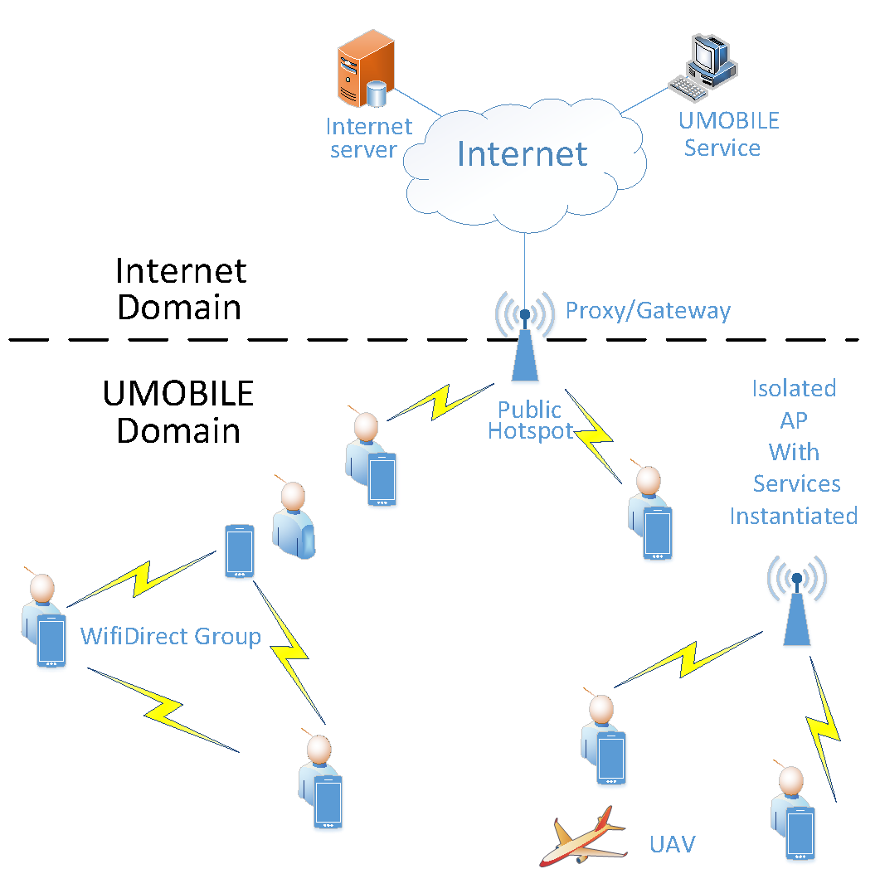
Figure 1 – UMOBILE architecture
In order to provide opportunistic communications, a set of devices must support UMOBILE architecture:
- UMOBILE-enabled mobile devices (i.e., smartphone, tablet), used to send and receive participatory data (e.g. photos, short messages) as well as opportunistic data (e.g. atmospheric pressure, temperature, noise, people anxiety levels, roaming patterns).
- UMOBILE-enabled hotspots able to collect and relay relevant information (e.g., alert messages, instructions from emergency authorities), host some instantiated services (see Section 5) or store collected data, check its validity and perform computational functions (e.g. data fusion) to increase the value of the information to the civil authorities.
- UMOBILE-enabled UAV devices or other vehicles able to collect and relay relevant information and connect two isolated areas.
- UMOBILE-enabled wearable device, as equipment of each member of the rescue/security team (e.g. Raspberry + GoPro as a rough suggestion, activity tracker)
- UMOBILE-enabled gateways/proxies provides interconnectivity between UMOBILE domain and the Internet domain.
The UMOBILE architecture must be able to work in the different areas of action detailed in D2.1 [3]. Therefore, depending on the situation, UMOBILE architecture must adapt to the environment to achieve the best performance. So, for example, UMOBILE normal mode of operation can be using ad hoc networking in order to share the information between peers in a decentralized way, offloading communications from core network. On the other hand, in remote or disrupted emergency areas, UMOBILE must use DTN techniques to propagate the information from the source to the destination. To support such scenarios, the application servers which provides UMOBILE services could be able to migrate some services from the Internet and operate locally within the UMOBILE domain. For instance, the UMOBILE services could be executed at the public hotspots (as depicted in Figure 1) in order to mitigate the network latency regarding the challenged conditions (e.g., intermittent connectivity, limited bandwidth at the backhaul). This approach is the key benefit of service migration module which can improve the QoS for the end users, the details of this module is presented in Section 4.4.
In UMOBILE, content can be named using tags/keyword, aggregating content by similarities, simplifying the naming scalability issues in the NDN approach and the search of content in the UMOBILE network. This approach is further detailed in Section 4.1. UMOBILE architecture must support different network technologies. UMOBILE architecture must support the ability to communicate with a wide variety of underlying protocols, implementing convergence layers for several underlying technologies, like 802.11, cellular (3G/4G), satellite, Bluetooth communication, etc. The minimum set of technologies comprises 802.11 and Bluetooth, since these technologies are the ones already presented in the UMOBILE demo scenarios.
Figure 2 – UMOBILE data networking ICN layer
The data networking layer of the UMOBILE architecture defines an ICN architecture extending NDN architecture [8] with a context detection (different kind of services and/or mobile scenarios) and a DTN/social routing mode support. It consists of three basic components (Fig. 2): context plane, content storage plane and routing plane. These components are further detailed in Section 4.

UMOBILE-enabled Proxy/Gateway
Some applications, such as instant messaging application in emergency scenarios, requires interaction with users connected via the fixed network, i.e. a user can access to the service remotely when they are at home or in the office.
In order to provide connectivity between the opportunistic UMOBILE network and the fixed network (IP network), we devise a UMOBILE Proxy/Gateway able to translate interest packets to HTTP requests and vice versa.
As depicted in Figure 3, the UMOBILE Proxy/Gateway can be placed in a Public Hotspot, or AP. This device should have two services, one that translates UMOBILE interests into HTTP requests and another that converts HTTP GET requests into UMOBILE interests.
In order to do that, we can use as starting point for the implementation of the UMOBILE proxy/gateway, we will use the HttpProxy application of the NDNx project [21].

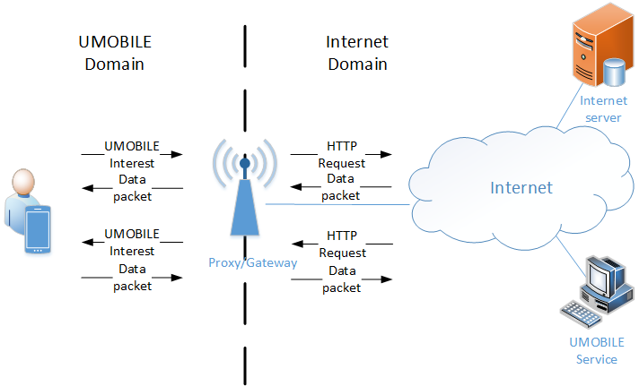
Figure 3 – UMOBILE proxy/gateway

UMOBILE modules

Content Plane
The content plane consists of the content store and caching functionalities of the UMOBILE ICN architecture. This plane is responsible for fragmenting the locally published data objects, and opportunistically advertising the cache summary of delay-tolerant data objects. In UMOBILE we will propose a new naming scheme based on keywords.

Naming
The discovery and invocation of services/applications in the networking vicinity of a user build on a naming scheme that enables the fine-grained description of the desired information.
To this end, UMOBILE builds on the observation that mobile computing is largely application-centric, in the sense that users tend to access information using purpose-built applications. Application-centricity presents a series of important characteristics:
- Applications inherently support the structuring of the name space within their semantic context. In turn, instances of the same (or similar) application can share the same name space in describing the related information e.g., categories in a news application.
- Applications are inherently used for computation, enabling the (lightweight) processing of content/information e.g., searching, sorting data or computing a route.
Taking these features into account, UMOBILE names are composed of two main parts (see Fig. 4):
- Fixed Hierarchical Part. It follows the hierarchical naming scheme of NDN and its purpose is to guarantee compatibility between instances of the same or different services/applications. Application developers can define their own hierarchical name spaces, enabling the communication between different instances of the application e.g., /NewsApp/politics/international. Further enabling communication between different applications goes through naming conventions that can build on the currently followed categorization of applications in popular application markets e.g., extending “/Travel & Local/” in Android App Market, to “/Travel & Local/Car Rentals”.
Moreover, application developers can also define suffixes corresponding to specific functionalities within their applications (in addition to static content), enabling this way the sharing of computation e.g., the name /MyTravelAdvisor/Top10Restaurants is used to identify the list of the top-10 restaurants in a certain area. The Hashtag part of the name, described below, is used to define the sorting criteria and the selected area.
According to our initial design this part of the name will have to be an exact match in order for the request to be formed. That said, however, it will be difficult for users to imagine the different parts of the name that the application developer has defined.
- Hashtags. The second part of the name comprises of hashtag-like keywords, which the application developer can add to the application. The exact semantics of the hashtags depending on whether the fixed hierarchical part of the name corresponds to static content or an application function(ality). In the former case, these keywords are used to semantically annotate the static content. This feature enables the partial matching of requests with available cache or routing/forwarding entries i.e., given an exact match in the fixed hierarchical part of the name, hashtags can be used to support approximate matching enabling the search of information in other devices.
When the fixed part of the name identifies a certain application function(ality), the hashtag part of the name enables the passing of adequate parameters. In the aforementioned example of the MyTravelAdvisor application, the complete name included in a user request can have the fixed hierarchical part /MyTravelAdvisor/Top10Restaurants and the hashtags \#userrating, \#areaY, \#indian indicating that the user is interested in the top-10 of the indian restaurants in areaY, according to users ratings. The submission of hashtag values is guided by the application GUI and can include both predefined value ranges e.g., the sorting criteria for the top-10 restaurants, and free text fields e.g., a user requests /MyNewsApp/politics/search #Syria #negotiations to use the search function of MyNewsApp in order to find anything related to negotiations for Syria. In another example, an application following the naming conventions of the app market place issues a request for the name /news/politics/search #Syria #negotiations, which can match any application supporting a search function.
Figure 4 - UMOBILE keyword-based naming scheme
We believe that the naming-scheme presented above can be rather efficient in narrowing down the range of the services to be executed and therefore, the results that will be returned to the user.

Below we include example naming schemes for the proposed applications in Section 2.2:
- Recommendations:
A user is walking on Oxford Street in London and wants to buy men’s clothes that are on sale.
Fixed Hierarchical Part: /ShoppingApp/Clothes/Men
Hashtags: \#London \#OxfordStreet \#Sales
- Chat:
A user would like to participate in a chat with other parents of the same class of their children school, in case of emergency.
Fixed Hierarchical Part: / EmergencyApp /Chat
Hashtags: \#SchoolName \#3rdGrade
- Instant messaging:
In this scenario, a user want to establish communications with any fire station in central London to provide information about a fire.
Fixed Hierarchical Part: / EmergencyApp /InstantMessaging
Hashtags: \#CentralLondon \#FireStation
- Emergency channel:
In this scenario, a user knows that a fire has broken out within the university campus in Xanthi and is looking for an evacuation plan.
Fixed Hierarchical Part: /EmergencyApp/Xanthi/Fire
Hashtags: \#UniversityCampus \#EvacuationPlan
- Local News:
A user is willing to find gigs and live music in central London.
Fixed Hierarchical Part: /NewsApp/arts/exhibitions
Hashtags: \#CentralLondon \#Music \#Today

Context Plane
The context plane takes care of the collection, resolution, and storage of the context. The context can be related to the usage, user or the network context. The usage context can be retrieved using metadata included in data packets, in order to differentiate the characteristics of different services. This information must be used to adapt the routing options to the requirements of each service. The user context can be retrieved based on local connectivity as well as device usage, mainly to be used for the social forwarding engine (Section 4.4). The network-condition context can be retrieved and used to adapt the routing decisions to the area of action (e.g. crowded urban area or sparse network) and the condition of each network interface (connected/disconnected, packet loss, etc). This could also differentiate the mode of operation between e.g., connected and disconnected mode. This information can be used to decide what is the best network interface for sending a certain packet.

Usage context
In order to differentiate the network requirement for each one of the UMOBILE applications, we need to retrieve information from the application data. To this end, the usage context module is responsible of retrieving this information from the application data using metadata included in data packets. This information must be used to adapt the forwarding options to the requirements of each service (e.g. providing more priority to some services). Moreover, services are often faced with stringent requirements in terms of performance, delay, and service uptime. On the other hand, little is known about the performance of applications in the network, for instance the response time variation is induced by network connectivity and traffic load. In response to these concerns, there has been significant interest in the usage context how the applications and services behave at the end users’ device. The usage context information accommodates the forwarding strategies to be adaptive to the various network conditions and service requirements. This significantly improve the content and service delivery such that the service requirement can be satisfied.
To retrieve the usage context, UMOBILE applications are integrated with the service monitoring where usage context (e.g., service response) is collected automatically from the users’ devices (e.g., smartphone).
Since, we will use NDN as a reference for our ICN approach, for this purpose, we will use the already defined in the NDN data packet MetaInfo field.

Data ::= DATA-TLV TLV-LENGTH
Name
MetaInfo
Content
Signature
Fig 5 – NDN Data packet
The MetaInfo field options used for each type of traffic will be defined in further deliverables.

User context
User context is captured based on local connectivity as well as device usage. A social routine inference service inserted into the UMOBILE is a non-intrusive service which resides on the end-user device. By non-intrusive it is meant that this service takes advantage of the natural networking footprint that is overhead by devices, be it via Wi-Fi, Bluetooth, as well as any other means (e.g. LTE Direct). In UMOBILE, however, the effort will be focused on short-range wireless in the form of Wi-Fi and Wi-Fi Direct.
The operation of this module starts by having sensing data begin collected by mobile devices, by means of a cooperative sensing functionality. Although the proposed cooperative sensing middleware allows the configuration of any sensor available in a mobile device, the proposed setting is able of collecting raw sensing data about users' roaming and relative location, by using the Wi-Fi interface; about users' social interactions, by using the Wi-Fi and Bluetooth interfaces, and about users' behavior, e.g. by using data concerning device usage.
Such “smart” captured data (in contrast to raw data) is then made available to a contextualization and behavior inference module as well as to the routing/data sharing module. The data shall reside on the end-user devices only, so the UMOBILE system obeys to the most recent EU rules concerning data privacy.
The contextualization and behavior inference module then integrates specific models. For instance, a USENSE mobile device may present a roaming preferences model, where the intent is to consider personal preferences in terms of visited wireless networks. Or, it may contain a model that relates with the need to share data opportunistically based on frequency or volume of wireless contacts. These models are defined by the user, based on specific parameters. The identified user's context is then used, together with the collected sensing data, to infer patterns of user behavior.
The inference process may be distributed among personal devices or may also include cloud computing entities, depending on the amount of data to be analyzed, the required learning algorithms, as well as the delay tolerance and privacy levels of applications. Similar distribution of computational effort may be needed to adjust contextualization modeling, by considering quantifiable social parameters, and by adjusting them to the roaming dynamics that can characterize user’s behavior with an adequate level of assurance. Some aspects that are considered in the notion of user context are:
- Social trust circles. These correspond to networks of devices owned and carried by users that share affinities, wishes, or interests. Trust circle computation assist in collective inference, derived not only from physical proximity, as well as from social proximity. Examples of trust circles are groups of friends; familiar strangers interested in a specific event.
- Social roaming footprint. The footprint that both individual and collective users exhibit when roaming around. Derived from wireless connectivity, it incorporates aspects such as duration of visits; common local places and paths.
- Personalized recommendations. Recommendations are filtered by the devices based on the personal and individual affinities of each user.

Network context
Deriving from the different scenarios detailed in D2.2, we extracted 3 different network context that UMOBILE architecture must cope with. These network contexts are detailed below:
- Wi-Fi hotspots w/ or w/o back haul internet connectivity
The first case (Fig. 6) includes a network scenario where a set of users are connected to a Wi-Fi hotspot that centralizes the communications inside a Basic Service Set (BSS). Each Wi-Fi hotspot can be connected to the Internet, or it can be connected to another Wi-Fi hotspot providing interconnectivity between different Wi-Fi areas.
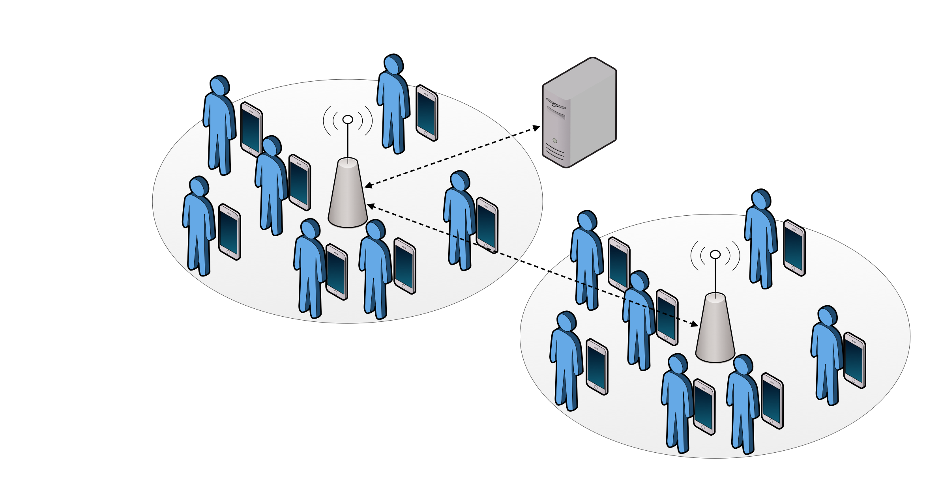
Figure 6 – Wi-Fi hotspot network context
- Opportunistic networks based on Wi-Fi-direct
In the second case, we focus on a network scenario where users must deal with opportunistic communication. That is, users do not have pervasive connection to the Internet, and they can have temporary encounters with other users, creating temporary connections between them. There are different cases of opportunistic contexts that we take into account in UMOBILE, as depicted in Figure 7:

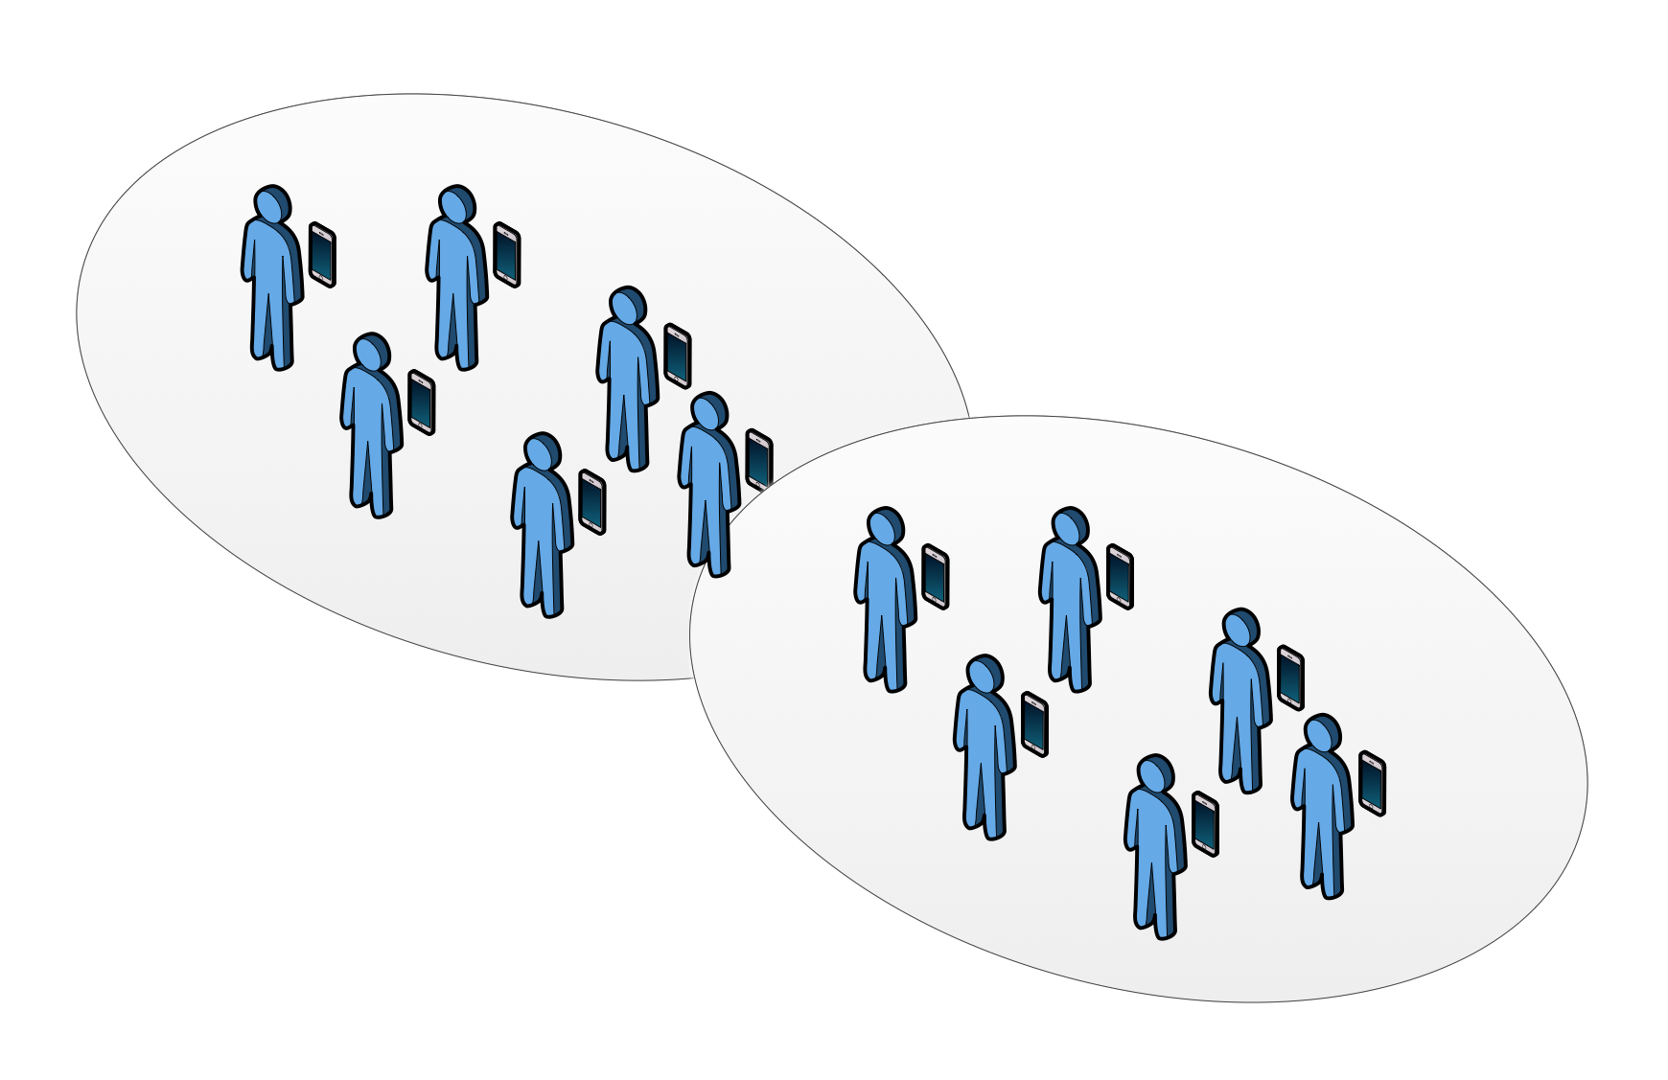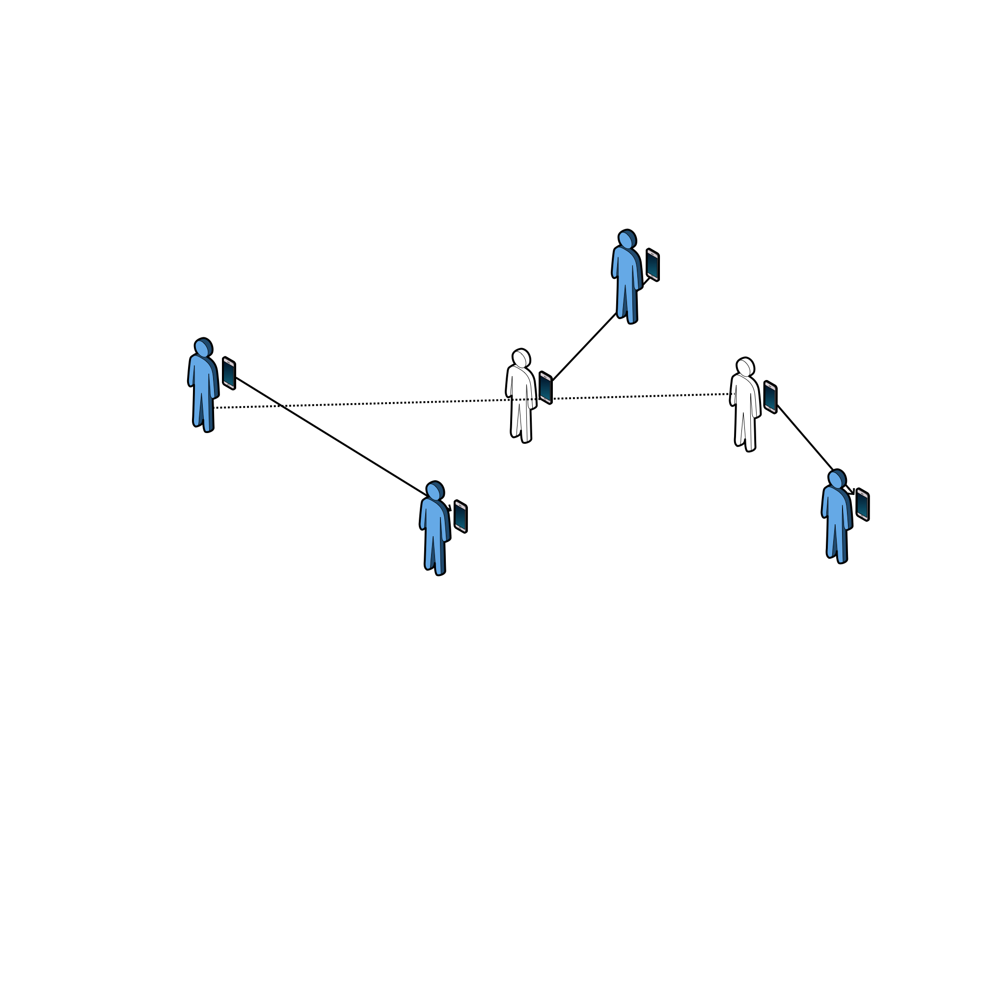
- Users groups b) Opportunistic users contacts

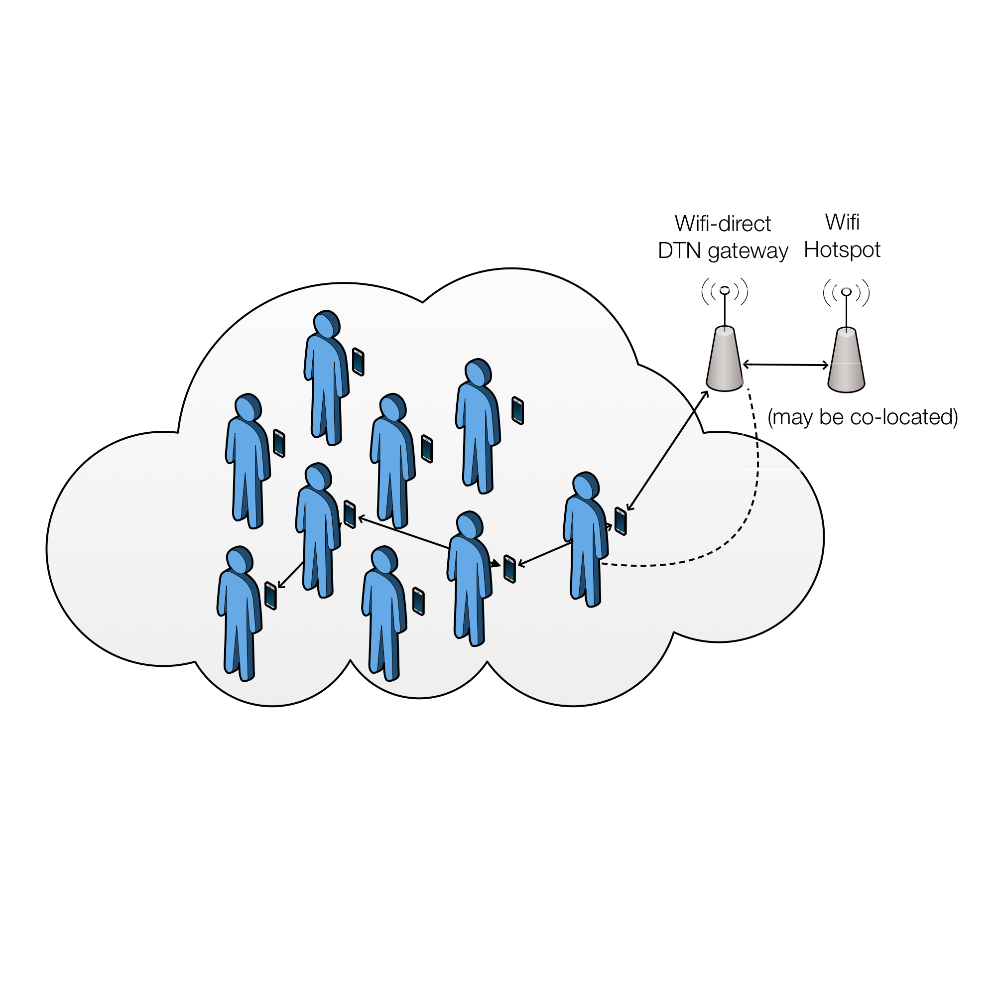
- Opportunistic network context with gateway
Figure 7 – Opportunistic network context

The first example (Fig. 7a) shows two formed groups of users connected between them using Wi-Fi Direct connectivity. The second example (Fig. 7b) shows a set of different users that have sporadic contacts between them without forming a group between all the users. The third example (Fig. 7c) shows a set of users that can use opportunistic communications between them in order to read a gateway, that can be co-located in the Wi-Fi hotspot or not.

- Poorly connected/isolated areas
The last network context (Fig. 8) takes into account the scenario where a set of users are isolated from the network, but a mobile device interconnects them with the rest of the network using DTN capabilities. This mobile device acts as a data mule, and it can be a UAV device or any other vehicle, such as a public vehicle. Delay-tolerant forwarding can be beneficial in cases where data needs to be forwarded over vehicles, such as UAVs or emergency vehicles. This kind of connectivity can be deployed to provide communications in remote areas or in emergency cases. In addition, UMOBILE architecture also allows services to be run locally within the isolated areas in order to offload the communication over the intermittent link as well as enhance the QoS. This can be facilitated by the service migration module where the service at the mainframe can be migrated to the local access point by exploiting DTN capabilities. Nevertheless, the local access point may need to interact with the mainframe, for instance there is a new update for the operating service or local access point synchronises the usage data with the mainframe.

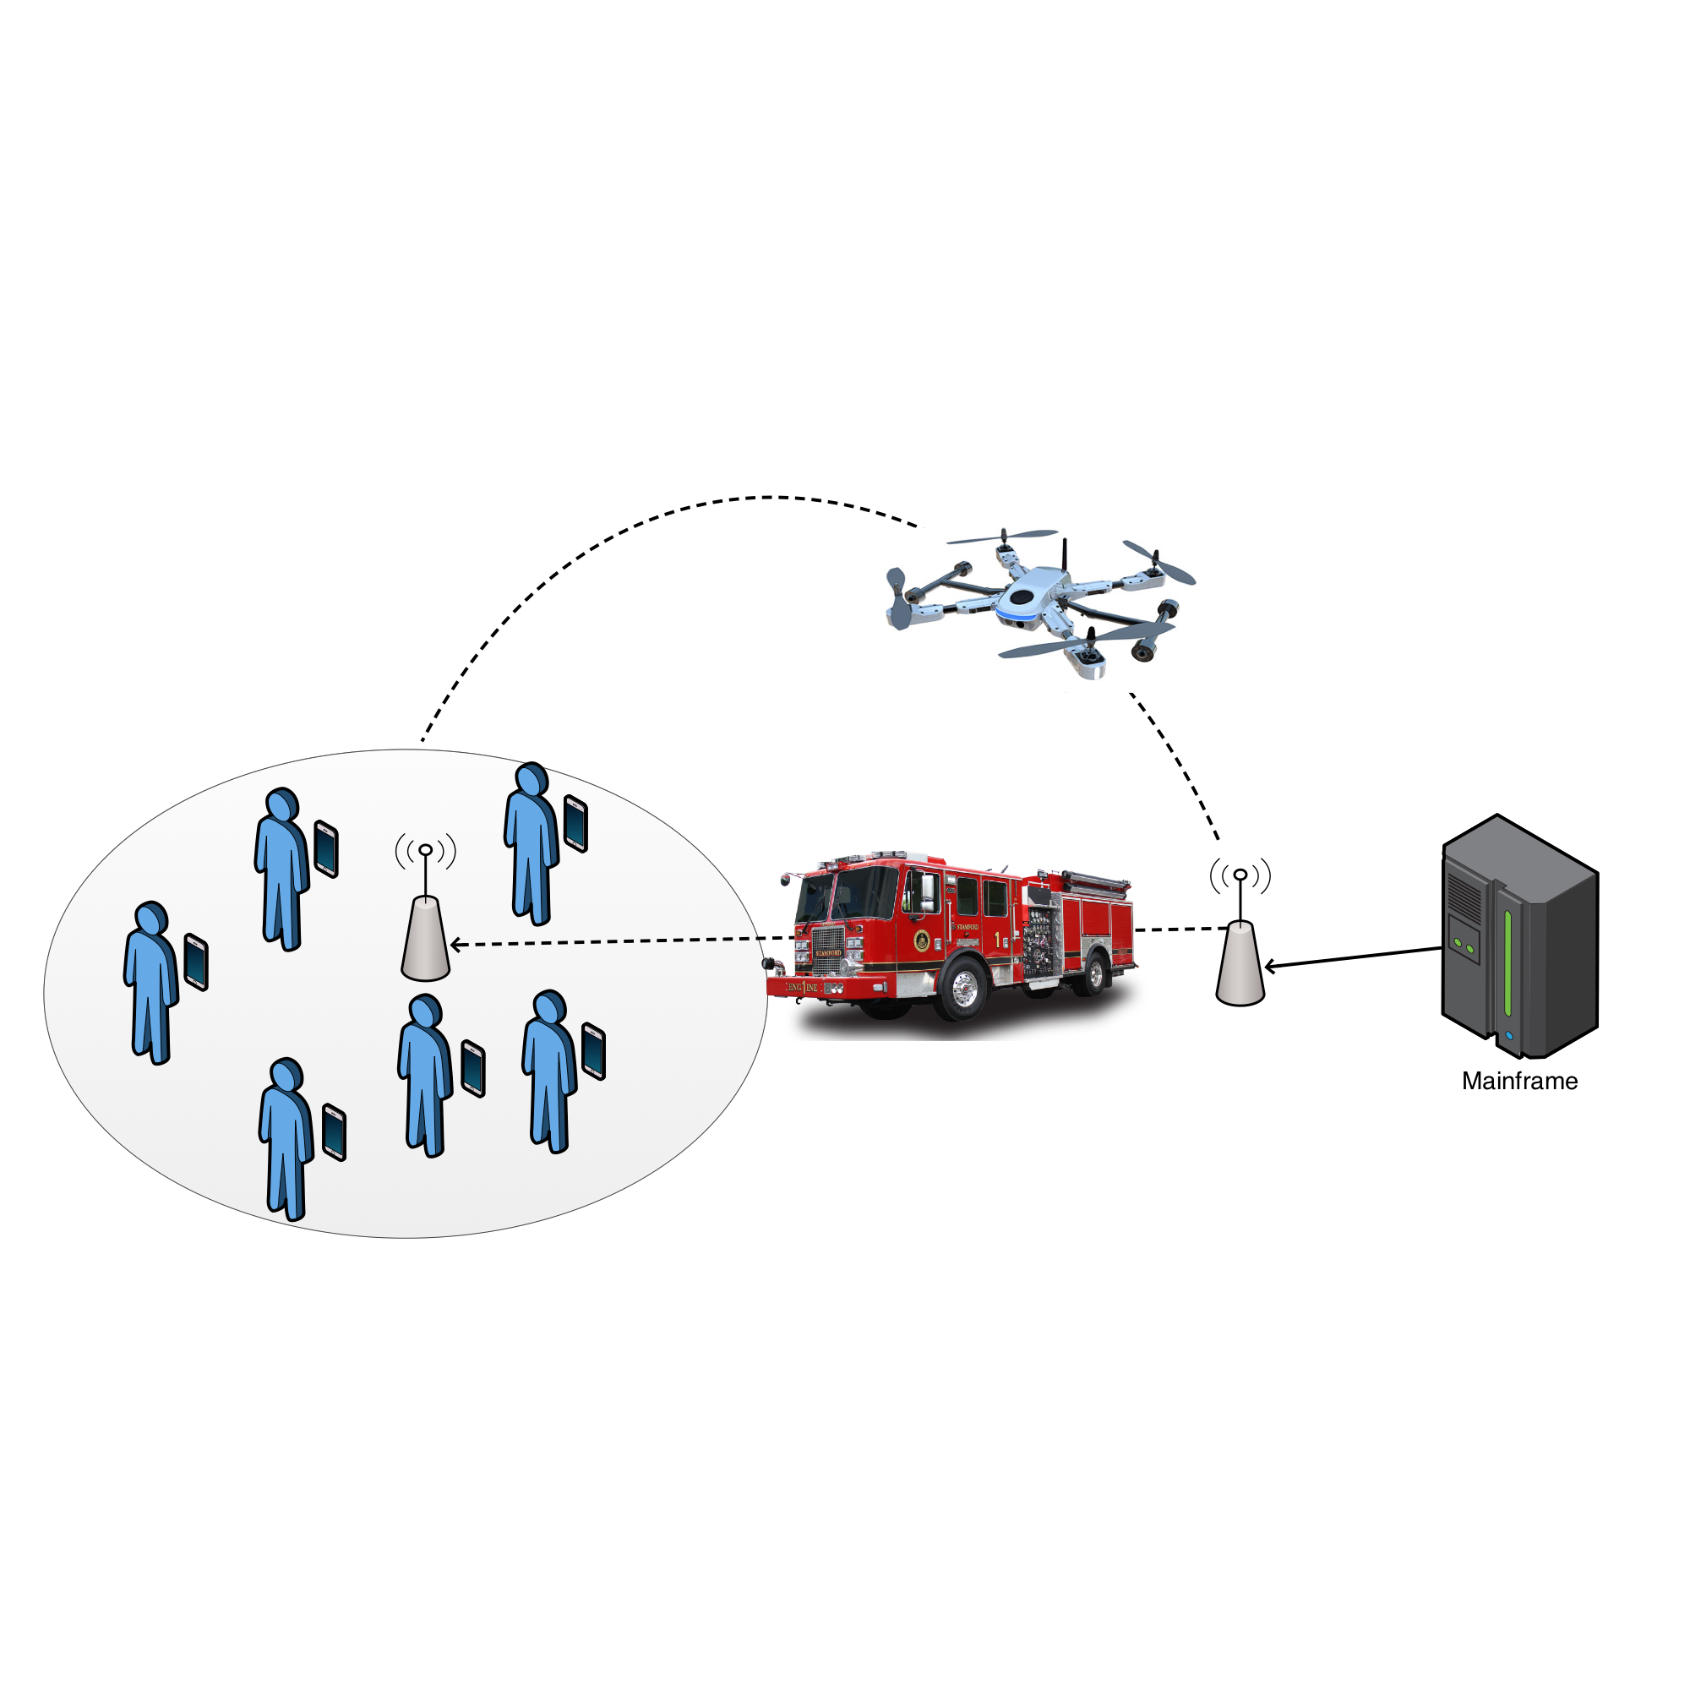
Figure 8 – Isolated areas network context
Information-Centric Connectivity
Through their mobile devices, users are presented with a multitude of opportunities to access information available in their networking vicinity in the form of opportunistically cached, pre-fetched/downloaded or locally generated content and/or services/applications providing static or dynamically generated content. Depending on the networking environment, information can reside at a wide range of accessible network locations and application level user dynamics, as well as any explicit differentiation of accessible services and/or content, contribute to the expectation of information diversity in these locations. In turn, awareness of the availability (or expectancy) of information in the networking environment can lead to connectivity decisions that reflect user interests, thus facilitating or even enabling the otherwise impossible access to the desired information.
For this reason, we propose that UMOBILE must enable information-centric connectivity aimed at discovering the networks enabling or facilitating access to the desired information. In essence, information-awareness is introduced at the link layer, supporting connectivity decisions per wireless network interface. In a characteristic use case (Fig. 6), the selection of a Wi-Fi AP can be driven by the matching between the user content interests and the currently available content at the AP and either opportunistically cached or pro-actively pushed there. In another example case (Fig 7a) where some users form a group without using an AP, a Wi-Fi BSS is carefully setup and selected by UEs to enable the exchange of information for a local event e.g., photos taken during a concert. This way, it is expected to enhance user experience as information-centric connectivity decisions bring the user closer to the desired information, reducing latencies, along with network traffic.
In order to provide information-centric connectivity several options are available for Wi-Fi interfaces. The first one is the Generic Advertisement Service (GAS) of IEEE 802.11u [16], which specifies a frame format and exchange process. The recently announced Wi-Fi Neighbour Awareness Networking (NAN) protocol [17] also further supports a low energy consumption device discovery mechanism enhanced with publish/subscribe primitives that can serve the same purpose.
Information availability is further expected to improve when a connectivity decision either leads to the desired information or not e.g., accessing photos in the aforementioned example. Note that in this context, these benefits come without the currently imposed need to search for information upon the time and energy consuming network association process. This comes in sharp contrast to a substantial body of work on service discovery, which, in most cases, assumes the establishment of connectivity between participating devices, before any service discovery protocol is employed (e.g., Jini, UPnP). At the same time, the ability of UEs to intelligently discover information in their networking vicinity enables new opportunities for network operators, content and service providers, or even users themselves, to provide access to information with dedicated, low cost equipment (e.g., APs, UEs), decoupling information provisioning from Internet access.

Data sharing plane

Forwarding
The core of our information-centric communication model lies in the usage of Interests issued by clients (pull-based model) or content providers (push-based model). In order for these Interests to be successfully delivered, a decision must be made on whether, when and to whom an Interest should be forwarded. Given the diverse application requirements, along with the varying networking conditions that may span from continuous high-speed connectivity to intermittent disruptive communications, a collection of different forwarding strategies needs to be supported by the UMOBILE architecture.
In particular, we envision a per-namespace selection of the forwarding strategy and we divide the forwarding strategies that UMOBILE will support into four main categories:
- Existing NDN forwarding strategies, such as best route, broadcast, client control and NCC.
- Delay-Tolerant NDN strategies, which are similar to the existing NDN forwarding strategies but support increased timer expiration values.
- DTN tunnelling strategies, where opportunistic forwarding is exploited for DTN nodes that interconnect ICN nodes.
- Opportunistic forwarding based on users’ interests and their dynamic social behaviour.

Forwarding Module
All basic forwarding decisions are made in the Forwarding module, a central part of the UMOBILE platform. In particular, the Forwarding module is responsible for selecting the optimal way to forward packets, based on the following inputs:
- Usage context (e.g. packet priority, application delay-tolerance, user delay-tolerance).
- Network context (e.g. Wi-Fi Direct connectivity, UAV connectivity).
- User context (social information).

Forwarding strategies
In this subsection, we describe the forwarding strategies that the UMOBILE platform will support.
Typical NDN
Interoperability between UMOBILE and NDN necessitates that the typical NDN forwarding strategies are also supported. In particular, UMOBILE will include the following NDN strategies:
- Best Route: This strategy forwards Interests to the interface with lowest routing cost.
- Broadcast: The broadcast strategy forwards Interests to all eligible interfaces.
- Client Control: This strategy allows a local application to choose the outgoing face of each Interest.
- Ncc[22]: This strategy, initially implemented for CCNx, is capable of employing multiple Interfaces to forward Interests, based on a prediction function.
Delay-Tolerant NDN
In the framework of the UMOBILE project, we devise a new set of forwarding strategies as a means to support scenarios involving long end-to-end delays but short hop-by-hop links. Typical use cases under this category are transmissions involving data ferries (e.g., UAVs). More specifically, we provide delay-tolerant characteristics to the strategies described in 4.3.1.2.1 by extending specific timers and modifying Interest and Data packet pipelines to exploit Interfaces that become available in a future moment.
NDN & DTN tunnelling
This forwarding strategy resides only at NDN-DTN gateways, effectively interconnecting NDN nodes over DTN links. Typical use cases for this type of connectivity are opportunistic networks (e.g., festival or emergency communications). Implementation-wise, NDN faces are translated to DTN hostnames, so that each NDN-DTN Face corresponds to a single DTN node within the DTN island. This way, the NDN forwarding engine actually delivers the Interest and Data packets to the DTN protocol. Then, DTN forwarding strategy is applied, and attempts to forward the Data/Interest packet to the specified DTN host. The starting point for DTN forwarding strategies is Tecnalia’s HURRywalla implementation [15].
Social-aware data-centric forwarding strategy
In order to perform opportunistic forwarding based on users’ interests and their dynamic social behaviour, the forwarding module includes some changes in relation of used tables and is expected to comprise three types of engines:
- A routing engine: responsible for the computation of the social weights.
- A forwarding engine: responsible for deciding whether packet replication should occur based on the level of social interaction towards specific interests.
Fig. 9 shows our envisioned forwarding strategy. A first observation is that in an opportunistic setting, the forwarding module makes no use of the NDN forwarding information base (FIB), since interest packets are not forwarded in the direction of potential sources: interests are carried by mobile nodes. Nevertheless a more greedy approach can be foreseen in which interest could be forwarded based on the social weight towards potential sources (similar to the algorithm used by dLife).
A second observation is that each entry on data or interest tables has a time-to-live (TTL), where i) data TTL refers to the usefulness of the content; and ii) interest TTL expresses the time in which a node is interested in a given content. It is worth mentioning that the temporary tables have their entries erased and replaced upon a new encounter.
Figure 9 – Social data forwarding
Data Structures
In the proposed node architecture, opportunistic networking is done based on persistent and temporal data structures, as shown in Fig. 9. Persistent structures are:
- Data Cache (DC) – Similar to the Content Store on NDN - responsible for holding information concerning the content carried by the current node. The content stored here allows for the implementation of the Store-Carry-Forward paradigm seen on DTN, in which the current node shall carry content to those with whom it is socially well connected and that are interested on it.
- Carried Interest Table (CIT) – Similar to the PIT on NDN - responsible for keeping up-to-date information concerning the data interests of the current node along with its social weights (computed by SWM) towards other nodes with whom it socially interacts. This table also holds the interests of the current node (with SW set to infinity) and contains only the information relevant from the SWR for taking forwarding decisions. The different towards the NDN PIT is that the stored Interests are kept even after being “satisfied”, due to the replication strategy used by opportunistic routing. Interests are deleted based on its TTL.
Due to the intermittent nature of the connectivity wireless links, the forwarding module implements two temporary structures used while neighbor nodes have wireless contact:
- temporary Pending Interest Table (tPIT) – holds the list of interests seen by the encountered node and the social weights between itself and such interests. The list also holds the interests of the encountered node.
- temporary Carried Data Table (tCDT) - holds information about the data that encountered node is currently carrying.
Routing Engine
The routing engine encompasses three modules in order to compute social weights towards a specific set of interests (defined based on the SCORP [11] protocol):
- Social Weight Measurer (SWM) – responsible for keeping track of the contact duration between the current and encountered nodes. SWM maps this duration to the encountered nodes' interests. Based on that, this component computes the level of social interaction of the current node towards the interests that encountered peers have. This social weight determines how good the current node is to reach others with such identified interests. Social weight (SW) computation takes place at every hour as to allow for a better view of the dynamic social behaviour of users.
- Social Weight Repository (SWR) – responsible for storing the list of interests the current node comes across (obtained upon encountering a peer). SWR holds the interest, time it has been first encountered, and the cumulative duration of within a specific hour. Upon a new hour, contact duration is updated and the social weight towards each encountered interests is computed for the last hour by SWM. In the case, the current node still 'sees' such interest (i.e., respective peer node is still in the vicinity), time of first encounter is updated and contact duration is accounted by SWM for the new hour.
- Social Weight and Carried Data Gatherer (SWCDG) – responsible for obtaining the list of interests and social weight towards them of encountered node. This element is also responsible for obtaining information concerning the content carried by encountered nodes.
Social weight (SW) computation is triggered when a specific face notifies SWM of the presence of a neighbour node. SMW creates entries for this encountered node in SWR considering the interest information obtained by SWDCG. SWM keeps track of the contact duration between current and encountered nodes and updates SWR accordingly. Since nodes (i.e., their users) present different patterns of behaviour in different time periods, SW computation takes place in an hourly fashion. Then, SW information is written to SWR and updated to CIT. Information obtained by SWCDG from the encountered node is used to populate tPIT (with a view of its CIT) and tCDT (with a view of its DC).
Besides supporting the reception of interests and forwarding of data, the available faces also support the SWM and SWDCG forwarding elements. For the former, the faces shall provide mechanisms for neighbouring node discover to allow computation of SW. As for the latter, the faces shall be used to obtain information concerning the neighbouring node interests and SW towards them.
Forwarding Engine
In terms of the forwarding strategies the Decision Maker (DM) is responsible for deciding whether replication should occur based on the level of social interaction towards specific interests, based on the SCORP algorithm.
For the Data forwarding, the DM interacts with CIT and tPIT to obtain social information of the current and encountered nodes, respectively. Considering the forwarding elements and tables belonging to the current node, data packets it carries shall reach the faces for forwarding only if:
- The content that is in DC is not in tCDT; AND
- The encountered node is interested (entries with SW set to infinity in tPIT: in this case “/umobile/copelabs/videos/oppnet.mpg4” is forwarded to the encountered node); OR
- The encountered node has higher social weight (tPIT) than the current node (CIT) concerning their interaction with others interested on the content to be replicated (“/umobile/copelabs/papers/datasharing.pdf” is forwarded to the encountered node since its SW, 0.9 in tPIT, is greater than the SW of the current node, 0.2 in CIT).
Our starting point for UMOBILE’s forwarding module is the NDN forwarding daemon (NDF [13]), which shall be complemented and/or adapted with these forwarding elements and tables to allow for content-based, social-aware data sharing in opportunistic scenarios (cf. Section 6).

Flow control
Given the dynamic nature of the considered use-cases, UMOBILE does not rely on the existence of end-to-end flows between communicating parties. Thus, the concept of flowlets is rather interesting, to provide applications with different quality of service mechanisms to allow satisfactory levels for the content being exchanged.
This functional block oversees how flowlets are started between the involved entities as to allow better, QoS-based data exchange and provide special support to in-network caching. It may provide QoS on-demand, by understanding the needs for QoS and making sure the content reaches its recipients respecting the desired QoS levels as much as possible.
However, we consider flow control out of the scope of this deliverable, and we will detail the flow control for UMOBILE in D4.1 and D4.2, with a detailed specification of the proposed rate-regulation scheme.

Service Migration module

In this section, we describe the service migration module which is integrated within the UMOBILE architecture. The objective of service migration is to facilitate efficient and resilient service delivery from network operators/service providers to network edges in order to support the necessary Service Level Agreements (SLA) as well as accommodate service reachability in challenged networks [19]. As mentioned in D2.1 (use case scenarios), UMOBILE needs to support various challenged scenarios such as aftermath of disasters or in rural/remote network deployments or networks with limited backhaul capacity. Such challenged environments poses several challenges such as increased latency, intermittent connectivity etc. To address these challenges, we propose a resilient service migration platform that utilizes advances in lightweight operating systems such as Docker containers [20] to push service instances right to the network edge. Inside a local network, service migration module utilizes a name based routing/forwarding strategy providing the benefits of ICN. Within the UMOBILE architecture, we will utilise the NDN abstractions to carry out the name based routing/forwarding strategies. We also envision that our service migration module could be integrated with DTN to provide resilient access to services during periods of intermittent connectivity.

4.4.1 Service migration components
In this section, we present the fundamental building blocks of our service migration module as following. Notice that the components are logical which can be multiplexed on the UMOBILE devices (e.g., Wi-Fi access point, border gateway, UAV)
- Service Controller (SC): SC manages the mapping of publishers of services and subscribers of services. The SC offers the repository to store services and delivers the service image over the network. It regularly disseminates the list of available services including the updates from the service publisher to all nodes residing in the network. It also collects information from the network such as devices capabilities, topology information, service usage patterns etc. These information will be then used by the SC to make optimal service migration decisions.
- Service Publisher (SP): SP refers to the original content producer. SP’s register services by publishing the services to the SC.
- Service Execution Gateway (SEG): This is the point of attachment for clients which is usually a wireless access points deployed in UMOBILE network. A SEG provides a virtualized environment to store and execute services locally upon a user request at the edge. The SEGs also carry out the necessary translations between IP and NDN providing support to current IP based services as well as removing the need for changes to the end user equipment. SEGs provide information to the SC to carry out service migration decisions. Each SEG is hence required to collect information such as device usage (e.g., available memory, CPU load), network context (e.g., uplink bandwidth, delay, packet loss etc.) and usage context (e.g, popularity of service, average response time etc.). These data also corresponds to the context plane mentioned in section 3.1.
- Gateway (GW): This is responsible for connecting different domains (two separate networks). GW also carry out the necessary translations between the domains (e.g. NDN to IP and vice versa).
- Forwarding Node (FN): This is responsible for routing requests for services towards available copies. These nodes also cache services locally, thereby allowing local copies to be returned to the client (they do not execute services though).

4.4.2 Service migration operations
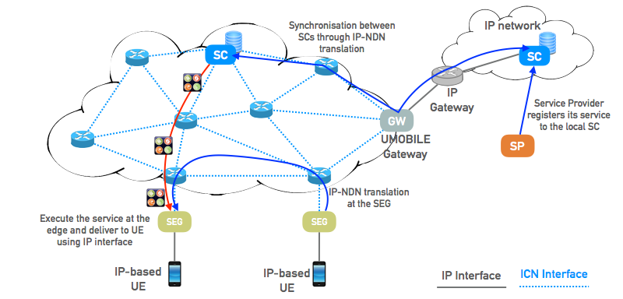
In this section, we explain the functionalities of service migration (figure 8)
Figure 8 An example of service migration operations
- Service Registration: The SP registers its service to the SC. The SP publishes a service image (e.g. Docker container) by uploading to the repository of SC. This operation is carried out using the IP.
- Service Discovery: Each SEG must be aware for the available services in their network. A SEG has to subscribe to the SC to retrieve the latest updates of available services. This information is responsible for indexing all services that are locally available in the edge network. Consequently, all SEGs have to periodically monitor the service usage indicated in the list of available services as well as the node usage and network condition (Service Monitoring). The intelligence of service migration lies on the decision engine, which is able to decide when the service should be migrated and where the service could be operated. We plan to utilise the information from context plane (details in section 3.1) in order to develop the heuristic algorithm for the decision engine, which will be integrated into the SC component.
- Service Resolution: To carry out the service resolution where the publisher is mapped to the subscriber, it utilises the functionality of Pending Interest Table (PIT) and Forwarding Information Base (FIB) as well as named-based routing. The Interest message of subscriber is broadcasted to the neighbours regarding the information in the FIB table. The PIT then stores all the Interests that a node has forwarded but not satisfied yet. Each PIT entry records the data name together with its incoming and outgoing interface(s). When the Interest message arrives to the publisher (i.e., a node who has the service in its cache), the Data message (e.g., service image) will be delivered back to the subscriber according to the information in the PIT.
- Service Migration: During the Service Migration phase, the service instances are pushed to the specific SEG where it’s executed. The Service Migration can happen between the SC and the SEG or between the intermediate Forwarding Nodes (if the service instance or image has been previously cached).
Service migration is proposed to support resilient service delivery in UMOBILE network. Within the UMOBILE project, our focus will be on challenged environments where networks have unstable/intermittent connectivity. To achieve this goal, we intend to integrate service migration module with various transmission strategies including DTN and IP. In this sense, it provides the added network resilience for various challenged scenarios, which is one of the key contribution of UMOBILE. By utilising a name-based routing and forwarding strategy, we also enable the added benefits of ICN. We will be developing optimization algorithms for making strategic service migration decisions and to ensure the necessary SLAs/QoS are met.

4.4.3 IP-NDN Translation
One of the key strengths of service migration is the interoperability with legacy clients and services through the use of a gateway based approach. A client can simply interact with the SEG via a well-known protocol (HTTP), leaving the SEG to translate wider interactions into the NDN network. This is possible because there is a direct mapping between the hierarchical RESTful API style addresses and NDN based service names. As RESTful API calls can contain parameters both within the URL and the body of the request, we only map the URL onto the NDN service name and put the request content into the body of the Interest message. The representation does not distinguish static content from services since everything is considered as a service. For example, raw static content is wrapped into a service publishing files in response to subscriptions. This generalisation therefore incorporates the efficient large content distribution as that in various ICN proposals. If a user requests a map within a certain bounding box from the Open Street Map, the coordinates of the location (bbox parameter) are embedded into a request which is used by a SEG to construct a service Interest.
To establish global connectivity with other peer networks as well as legacy Internet, we foresee a modified UMOBILE border gateway that establishes IP-level connectivity to other IP-based networks thus providing the necessary NDN to IP translation.

Conclusion

In this document, we defined an initial approach of the UMOBILE architecture ICN data layer. The proposed architecture aims to deal with the different areas of action defined in the document D2.1 for the UMOBILE project and tries to integrate the DTN and ICN paradigm in a single architecture able to perform in any of the scenarios defined.

References
[1] V. Cerf, S. Burleigh, A. Hooke, L. Torgerson, R. Durst, K. Scott,K. Fall, H. Weiss, “Delay-Tolerant Networking Architecture”, IETF RFC 4838, April 2007
[2] George Xylomenos, Christopher N. Ververidis, Vasilios A. Siris, Nikos Fotiou, Christos Tsilopoulos, Xenofon Vasilakos, Konstantinos V. Katsaros, and George C. Polyzos, A Survey of Information-Centric Networking Research. Communications Surveys Tutorials, IEEE, 16(2):, Second 2014.
[3] UMOBILE Project, “D.2.1 - End-User Requirements Report”, June 2015
[4] K. Scott and S. Burleigh. Bundle Protocol Specification. RFC 5050 (Experimental), 2007.
[5] G. Tyson, J. Bigham, and E. Bodanese, “Towards an information-centric delay-tolerant network," in Proceedings of IEEE INFOCOM Workshop on Emerging Design Choices in Name-Oriented Networking (NOMEN), 2013.
[6] I.Psaras, L. Saino, M. Arumaithurai, K. K. Ramakrishnan and G. Pavlou, Name-‐ Based Replication Priorities in Disaster Cases., 2nd Workshop on Name Oriented Mobility (NOM 2014) in conjunction with the IEEE INFOCOM, Toronto, Canada, 2014.
[7] Van Jacobson, Diana K. Smetters, Nicholas H. Briggs , Michael F. Plass, Paul Stewart, James D. Thornton, Rebecca L. Braynard, “VoCCN: voice-over content-centric networks”, in Proc. of international workshop on re-architecting the internet, Rome, Italy, December 2009.
[8] Networking Named Content by V. Jacobson, D. K. Smetters, J. D. Thornton, M. F. Plass, N.H. Briggs, R.L. Braynard. CoNEXT 2009, Rome, December, 2009.
[9] C. Tsilopoulos and G. Xylomenos, “Supporting Diverse Traffic Types in Information Centric Networks, ” in Proceedings of the ACM SIGCOMM workshop on Information-centric networking, Toronto, Canada, Aug. 2011, pp. 13.
[10] W. Moreira and P. Mendes, "Pervasive data sharing as an enabler for mobile citizen sensing systems." Communications Magazine, IEEE 53.10 (2015): 164-170.
[11] W. Moreira and P. Mendes, “Social-aware opportunistic routing protocol based on users interactions and interests,” in Ad Hoc Networks, ser. Lecture Notes of the Institute for Computer Sciences, Social Informatics and Telecommunications Engineering, M. H. Sherif, A. Mellouk, J. Li, and P. Bellavista, Eds. Springer International Publishing, 2014, vol. 129, pp. 100–115.
[12] W. Moreira, P. Mendes, and S. Sargento, “Opportunistic routing based on daily routines,” in Proceedings of WoWMoM, June 2012, pp. 1–6.
[13] Afanasyev, Alexander, et al. NFD developers guide. Technical Report NDN-0021, NDN Project, 2014.
[14] Zhenkai Zhu and Alexander Afanasyev, “Let’s ChronoSync: Decentralized Dataset State Synchronization in Named Data Networking” in Proc. of IEEE ICNP, Goettingen, Germany, October 2013
[15] Susana Pérez-Sánchez, Jose Maria Urteaga Cabero, Iñigo Urteaga, DTN Routing Optimised by Human Routines: The HURRy Protocol in 13th International Conference, WWIC 2015, Malaga, Spain, May 25-27, 2015
[16] IEEE Standard 802.11u, "IEEE Standard for Information Technology-Telecommunications and information exchange between systems-Local and Metropolitan networks-specific requirements-Part II: Wireless LAN Medium Access Control (MAC) and Physical Layer (PHY) specifications: Amendment 9: Interworking with External Networks," 2011
[17] D. Camps-Mur et al., "Enabling always on service discovery: Wi-Fi neighbor awareness networking," in IEEE Wireless Communications, , April 2015
[18] Arjuna Sathiaseelan, Liang Wang, Andrius Aucinas, Gareth Tyson, and Jon Crowcroft.. “SCANDEX: Service Centric Networking for Challenged Decentralised Networks”, In Proceedings of the 2015 Workshop on Do-it-yourself Networking: an Interdisciplinary Approach (DIYNetworking ’15), 2015
[19] Solomon Hykes and others. What is Docker? https://www. docker.com/whatisdocker/.
[20] NDN Packet Format Specification 0.2-alpha-3 documentation http://named-data.net/doc/ndn-tlv/data.html
[21] NDN HttpProxy. https://github.com/named-data/ndnx/tree/master/apps/HttpProxy
[22] ccnd 0.7.2 forwarding strategy http://redmine.named-data.net/projects/nfd/wiki/CcndStrategy

For the sake of simplicity, the example illustrates the Data Forwarding process taking place in the current node. However, it is worth mentioning that is concurrently taking place on the encountered node as well (The current node will send “/umobile/copelabs/soft/oi/oi.pdf” as the current node has interest in content matching “/umobile/copelabs/soft/oi”).

